Tennis Review Sheet
History
The word “tennis” comes from the ___________ word ________ which means “take it” or “play.” In 1913, the International Lawn Tennis Federation was founded. In 1977, “lawn” was dropped from its name. Thus, today it is the International Tennis Federation.
Tennis is an example of a lifetime activity. People can burn more ____________ per hour playing competitive tennis than playing volleyball, swimming, canoeing, hiking, playing softball, or golfing. Tennis can help you _______________ your leg strength, balance, speed, and agility. Tennis is great for ___________ coordination. Men and women of all ages and physical conditions can have ___________ with the game. Tennis is a thinking game that requires ____________ decisions. It also requires a high level of sportsmanship and etiquette.

Court Areas and Lines- Label the Tennis court
A. E. I.
B. F. J.
C. G. K.
D. H.

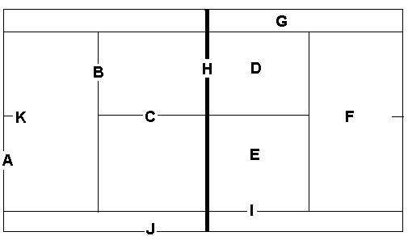
RULES
• Service begins from the ___________ hand court which is also the even court.
• A fault is an illegal serve either by foot fault or just not getting the ball into the proper court or having the ball not ___________ over the net.
• ______________ – the ball on a serve touches the top of the net but lands in the proper service court. If it was your first serve, you still have two more attempts. If it was your second serve, you have one more attempt. There is ______________ as to the number of let serves you can serve.
• The receiver must allow the ball to ______________ on the serve before he or she may play it.
• During a rally the ball may be hit without a bounce or with only one bounce. Only one person on a side may play the ball at a time in a doubles game.
• You are not allowed to make any ______________ of the net with your body, racket, or your clothing.
• You may reach over the net only to follow through with a stroke. But again, you may not touch the net.
• Only the person to whom the service is intended may play the ball on the serve.

In a doubles play the serving order should be controlled by the following rules:
• The pair who serves in the first game of each set shall decide which partner will serve first and the opposing pair decides the same for the second game.
• The partner who did not serve the first game shall serve the _________ game. The partner who did not serve the second game shall serve the ______________.
• The pair who receives the service in the first game shall decide which partner shall _______________ the first service and that player shall continue to receive service in the _____________ hand court.

Scoring
• A player must win at least __________ points to win a game, at least six games to win a set, and at least two sets to win the match.
• Zero points – _____________, one point – 15, two points – 30, three points – 40, four points – game.
• In a ___________ you have to win at least six games and be ahead of your opponents by ______________ games.
• If each player has won three points the score is deuce and one player must win two consecutive points in order to win. The first point after deuce is called advantage. ____________ if the server wins the point and ____________ if the receiver wins the point. If you win the ______________ and win the next ________________ you win the game.
• Players _________________ sides of the court after the first, third, and every subsequent odd game. The reasons for the change involve the ______________________(wind and sun) on the game.

Court Etiquette
• It is the server’s responsibility to check if the receiving team is ready for the serve.
• The server always announces the ______________ before serving. He must say the _____________________ team’s score first.
• The team _________________ to the ball is _______________ for making a “call” of in or out.
• Never run across another court area to retrieve a loose ball.
• Always have _______________ tennis balls in your possession when you begin serving.

Answer the following:
1. When you hit your forehand or backhand, which direction should your body or feet be facing?
To the front To the side
2. You are serving a game. After every point what should both you and your partner do?
You must switch sides You must switch who serves
3. How many players total are on the court when playing a game of doubles?
Two Four
4. On your serve, if the ball hits the net and still land into the service box, it is called?
Let Net
5. The server gets two chances to serve into the proper court. What is it called when neither serve goes into the court.
Fault Double Fault
6. The first serve of each game must start from what side of the center mark?
Left Right
7. You are playing a game of Doubles: How many games must be played in order for all players to get a chance to serve?
2 4
8. When playing a game you must make all the line calls for which side of the court?
Your side of the court The opponents side of the court
9. The part of the tennis court that always stays the same is called?
Service Court Sidelines
10. What is the name of the line you stand behind to serve?
Sideline Baseline

