Name: Class:
PICKLEBALL STUDY GUIDE
What is Pickleball?
Pickleball is a mini tennis like game that began in the Puget Sound region of the State of Washington USA. Though it has been around for about twenty years, the last five has seen tremendous growth. Inquires about the game come to the USAPA office from around the country and the world! It is played on any hard surface, has the same lines and dimensions as badminton courts only the net is lowered to the ground. Pickleball originated at the home of Joel Pritchard in the Seattle, Washington area in 1965.
The original purpose of the game was to provide a sport for the entire family. Pritchard and his houseguests, William Bell and Barney McCallum discovered that there wasn’t enough good badminton equipment for all of the families to play. Pickles was the family dog that would chase after the errant balls and then hide in the bushes, thus Pickle's ball which was later shortened to the namesake of Pickle-Ball.
Initially, families played Pickle-Ball in their backyards on a hard surface, on driveways, and on residential dead-end streets. Since the mid-1970's, Pickle-Ball has grown and expanded from a family activity game to paddle court sport with formalized rules. Now, over 20 years later Pickle-Ball is played in thousands of school P.E. programs, parks and recreation centers, correctional facilities, camps, YMCA's and retirement communities.
The Game
Pickleball is a simple paddle game, playing a special perforated slow-moving ball over a tennis type net, on a badminton-sized court. The ball is served underhand, without bouncing it from the court, and is served diagonally to the opponent's service zone. Points are scored by the serving side only and occur when the opponent faults (fails to return the ball, hits the ball out of bounds, etc.). The server continues to serve, altering service courts, until the server faults. A game is won by the first side to reach 21 points but will continue until won by a two point margin.

Serve Position:
Server can have one foot inside the baseline, as long as the other foot is outside at moment of serve.
Service Bounce Rule:
Following serve, each side must make at least one ground-stroke, prior to volleying the ball (hitting it before it has bounced).

Non-volley Zone:
A player cannot volley a ball while standing within the non-volley zone. When playing Pickleball the serve must be hit underhand and each team must play their first shot off the bounce. After the ball has bounced once on each side then both teams can either volley the ball in the air or play it off the bounce. This eliminates the serve and volley advantage and prolongs the rallies. To volley a ball means to hit it in the air without first letting it bounce. No volleying is permitted within the seven foot non-volley zone, preventing players from executing smashes from a position within the seven foot zone on both sides of the net. This promotes the drop volley or "dink" shot playing strategies, as Pickleball is a game of shot placement and patience, not brute power or strength.

Scoring:
There are actually three ways you can score a game in pickle ball. The first way is by playing 2of 3 games to 11. The second is one game to 15. And the third is by playing one game to 21 points. Each game a team must win by two points. Points are lost by hitting the ball out of bounds, hitting the net, stepping into the non-volley zone and volleying the ball, or by volleying the ball before the ball have bounced once on each side of the net.

The Serve:
Players must keep one foot behind the back line when serving. The serve is made underhand. The paddle must pass below the waist. The serve is made diagonally cross court and must clear the non-volley zone. Only one serve attempt is allowed, except in the event of a let (the ball touches the net on the serve, and lands on the proper service court). Then, the serve may be taken over. At the start of each new game, the 1st serving team is allowed only one fault before giving up the ball to the opponents. Only one service is allowed per side. If the serving team's score is odd then whoever is in the left box will serve (doubles) and if the serving team's score is even the other is in the right box will serve (doubles). If the serving team wins the point then the serving team will switch service boxes with their partner and serve again. In singles you serve from the right if you have an even score and left if your score is odd. You still switch service boxes when you score a service point.
The Volley:
To volley a ball means to hit it in the air without first letting it bounce. All volleying must be done with the player's feet behind the non-volley zone line.

Double Bounce Rule:
Each team must play their first shot off the bounce. That is, the first receiving team must let the served ball bounce, and the serving team must let the return of serve bounce before playing it. After the two bounces have occurred, the ball can be either volleyed or played off the bounce.

Faults:
Hitting the ball out of bounds · Not clearing the net · Stepping into the non-volley zone and volleying the ball

The Court
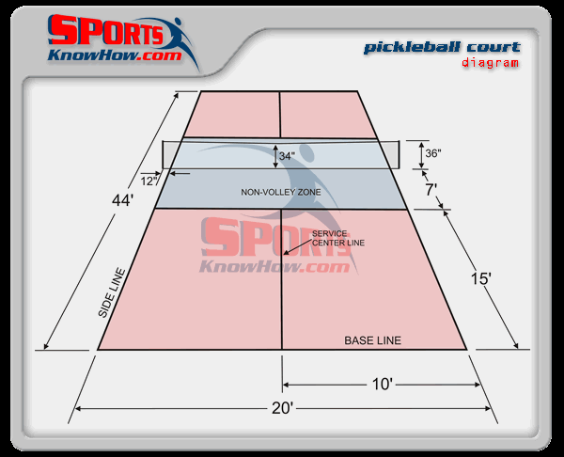

Court Dimensions:
The court dimensions are identical to a doubles badminton court. The court dimensions are 20' x 44' for both doubles and singles

Non-Volley Zone:
A non-volley zone extends 7' on each side of the net.

