**Golf Review Sheet**

**Name: Period:**

**Golf History:**

The game of golf as it is played today originated in ___________________ in the early fourteenth century. The first rules of golf were written in ____________ at St. Andrews Golf Club in Scotland. The first golf club in the United States, St. Andrew’s of Yonkers, New York, was founded in _____________. The ________________________ was established in 1894 to govern the game in the U. S. Today there are an estimated 23 million golfers in America alone.

**FUN FACTS!**

The ______________ is the largest sports organization in the world. There are about 40 million golfers worldwide. Walking _____________ of golf is the equivalent of _________ miles. Often business deals and networking take place over golf.

**Benefits of Playing**

If you ____________ while you play golf, you can get a good workout. Golf is a great stress reducer. Playing golf can help you with your _______________, especially if you stretch before and after you play. When you play with friends, you can socialize with them as you walk from one hole to another. Golf is __________!!!

**The Game of Golf**

The goal of every golfer is to try and take as few shots as possible on each hole – meaning that in golf the __________score wins. Regulation golf is played on a course consisting of 18 different holes. Each hole has ___________, ___________, and a ___________and a par rating of 3, 4, or 5. Varying combinations of these holes in any order on any course give it an overall par rating in the upper 60’s to low 70’s (most commonly 69-72) for all 18 holes. __________is determined by the length and design of a hole and is always the number of shots it should take a golfer to get to the green plus two putts on the green to put the ball in the cup. You can only use a _________ when you’re playing from the tee boxes at the beginning of a hole. Place your ball between the markers or no more than two club lengths behind- never ahead.

**General Etiquette**

When Golfing do not hit until the _________________ in front of you is out of range. Never underestimate your hitting limits. A golf ball travels with tremendous ____________ and can inflict severe injury. Should your ball go in the direction of other golfers you should shout the warning cry _________________. If playing a t a slow pace let faster groups of four players ___________________. Always avoid a lost ball by ____________ it throughout its flight. All golfers in your group should assist in the search. Never look for a ball for more than _________________.

**GOLF CLUBS**

The rules of golf allow a player to carry a maximum of ____________ in their golf bag during any competition. A traditional full set of golf clubs includes three or four woods, nine or ten irons (including wedges), and a putter. A general rule to remember about clubs is as the________________***,*** the________________***.*** The ________________woods/irons (1-5) are for ________________and the _________________clubs (6-9, & wedges) are for ______________**,** but more ______________shots. The putter (used on the greens) is the club that is essential to all golfers. Golf clubs are also made out of different materials (metal, wood, & graphite), in different styles (men’s & women’s), and different sizes (for taller or shorter/ stronger or weaker players).

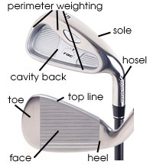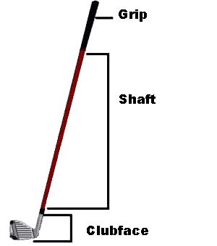

**Golf Courses**

Regulation golf is played on a course consisting of ________different holes.

Each hole has a ________________, _______________, and a ______________and a par rating of__________________. Varying combinations of these holes in any order on any course give it an overall par rating in the upper 60’s to low 70’s (most commonly 69-72) for all 18 holes. _________ is determined by the length and design of a hole and is always the number of shots it _______________take a golfer to get to the green plus two putts on the green to put the ball in the cup. The goal of every golfer is to try and take as _______________ as possible on each hole – meaning that in golf the _________score wins.

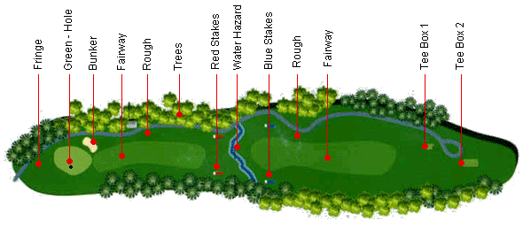

**6 COMPONENTS OF THE GOLF SWING**

**4 ASPECTS OF BACK SWING**

1. *BACK TO TARGET*
2. *HANDS OVER REAR SHOULDER*

**4 ASPECTS OF FOLLOW THROUGH**

1. *HIPS FACE TARGET*
2. *REAR SHOULDER CLOSER TO TARGET*