“Eat This Not That” Make up Assignment

- Collect 10 food labels from different foods
- Calculate the % of daily value that comes from a serving size of that food.
  - Divide the number of calories by 2,000 (the amount of calories most people need in a day) then multiply by 100 to make a percentage. This will tell you if the food is high in calories.
  - For example: A serving of potato chips provides 350 calories
350 ÷ 2,000 x 100 = 17.5
  - So, a serving of potato chips provides 17.5% of the calories you need in a day
  - Continue this for each of the 10 foods you collected
    - _______ ÷ 2,000 x 100 = ______% of the calories you need daily from _________________________________ (name of the food)
    - _______ ÷ 2,000 x 100 = ______% of the calories you need daily from _________________________________ (name of the food)
    - _______ ÷ 2,000 x 100 = ______% of the calories you need daily from _________________________________ (name of the food)
    - _______ ÷ 2,000 x 100 = ______% of the calories you need daily from _________________________________ (name of the food)
    - _______ ÷ 2,000 x 100 = ______% of the calories you need daily from _________________________________ (name of the food)
    - _______ ÷ 2,000 x 100 = ______% of the calories you need daily from _________________________________ (name of the food)
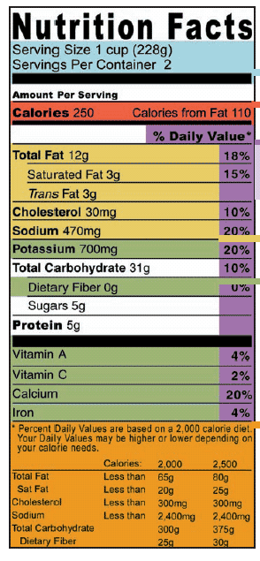
    - _______ ÷ 2,000 x 100 = ______% of the calories you need daily from _________________________________ (name of the food)
    - _______ ÷ 2,000 x 100 = ______% of the calories you need daily from _________________________________ (name of the food)
    - _______ ÷ 2,000 x 100 = ______% of the calories you need daily from _________________________________
    - _______ ÷ 2,000 x 100 = ______% of the calories you need daily from _________________________________
- Look at each food label and record the nutrient dense substances
  - The side of a nutrition label tells you what percentage of the Daily Value the food provides. If a food contains a higher % of the DV of a particular nutrient than the percentage of calories it provides, then that food is said to be nutrient dense for that nutrient. That means it’s a good source of the nutrient.

  - So if potato chips are 17% of my daily calories, but contain 35% sodium and 5% carbohydrate they are nutrient dense in sodium.
  - Record the nutrient dense substances for each food you collected
    - __________________________________ (name of food) is nutrient dense in ___________________________________________________________________.
    - __________________________________ (name of food) is nutrient dense in ___________________________________________________________________.
    - __________________________________ (name of food) is nutrient dense in ___________________________________________________________________.
    - __________________________________ (name of food) is nutrient dense in ___________________________________________________________________.
    - __________________________________ (name of food) is nutrient dense in ___________________________________________________________________.
    - __________________________________ (name of food) is nutrient dense in ___________________________________________________________________.
    - __________________________________ (name of food) is nutrient dense in ___________________________________________________________________.
    - ________________________________ (name of food) is nutrient dense in ___________________________________________________________________.
    - __________________________________ (name of food) is nutrient dense in ___________________________________________________________________.
    - __________________________________ (name of food) is nutrient dense in ___________________________________________________________________.
- Which food is the most nutrient dense?
- Which food is the least nutritious?
- Which food is the best source of vitamins and minerals?
- Which food should you probably avoid?

